

**UNICAT LEARNING ONLINE**

**Software Requirement Specification**

– Hanoi, Feb 2023 –

**Table of Contents**

*1. Product Overview 4*

*2. User Requirements 5*

*2.2 User Cases 6*

*2.2.1 Use Case Diagrams 6*

*2.2.2 Use Case Descriptions 7*

*3. Functional Requirements 13*

*3.1 System Functional Overview 13*

*3.1.1 Screen Flow 13*

*3.1.2 Screen Description 14*

*3.1.3 Screen Authorization 16*

*3.1.4 Entity Relationship Diagram 17*

*3.2 Admin: 18*

*3.2.1 User Manager 18*

*3.2.2 Course Manager 19*

*3.2.3 Course Request Manager 21*

*3.3 Tutor 23*

*3.3.1 Course Manager 23*

*3.3.2 Add Course 24*

*3.3.3 Update Course Manager 26*

*3.3.4 Request Course Manager 27*

*3.3.5 Add,Delete,Update Lesson 29*

*3.4 User 30*

*3.4.1 Profile Manager 30*

*3.4.2 Lesson Details Screen 32*

*3.4.3 Quiz Screen 33*

*3.5 Common feature 34*

*3.5.1 About 34*

*3.5.2 Homepage 36*

*3.5.3. Blog 38*

*3.5.4 Contact 39*

*3.5.5 Courses 41*

*3.5.6 Login 43*

*3.5.7 Register 44*

*4. Non-Functional Requirements 45*

*4.1 External Interfaces 45*

*4.1.1 User Interfaces 45*

*4.1.2 Hardware Interfaces 46*

*4.1.3 Communications Interfaces 46*

*4.2 Quality Attributes 46*

*4.2.1 Usability 46*

*4.2.2 Availability 46*

*4.2.3 Performance 46*

*4.2.4 Security 46*

*4.2.5 Safety 47*

*4.2.6 Support Documents 47*

*5. Requirement Appendix 47*

*5.1 Business Rules 47*

*5.2 Common Requirement 47*

# 

# *1. Product Overview*

Online learning system is a system that allows users to access available courses, a system that provides information about the completion of courses, and discussions about questions.

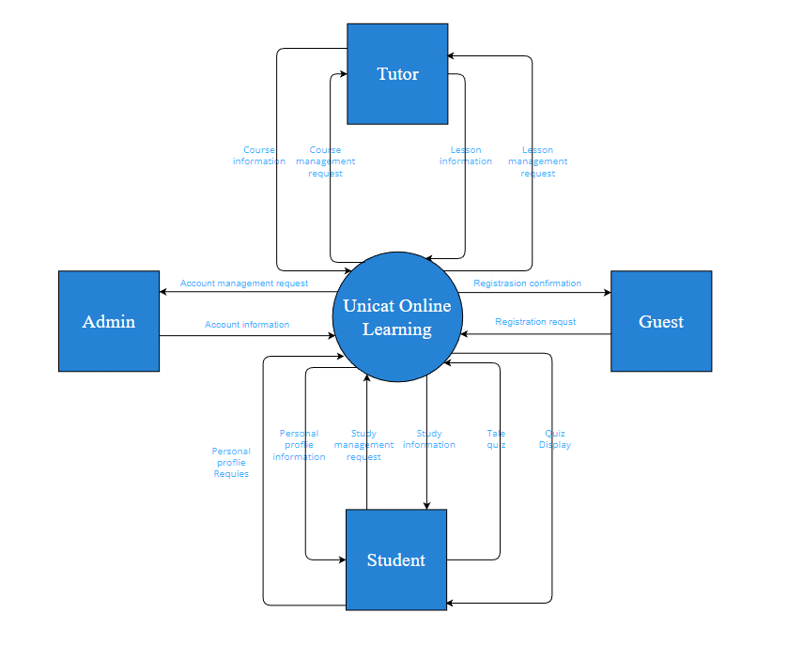

*Figure 1: Context diagram*

# *2. User Requirements*

***2.1 Actors***

|  |  |  |
| --- | --- | --- |
| **#** | **Actor** | **Description** |
| 1 | Admin | The Web manager who manages the web’s contents, manages the publishing course,... |
| 2 | Tutor(s) | The person who can create a new course and update the course. |
| 3 | Student(s) | The registered user who joins in courses, practises, takes the test. |
| 4 | Guests | User who does not login. Only view course information but not lesson details |

*Table 1: Actor*

## *2.2 User Cases*

### ***2.2.1 Use Case Diagrams***

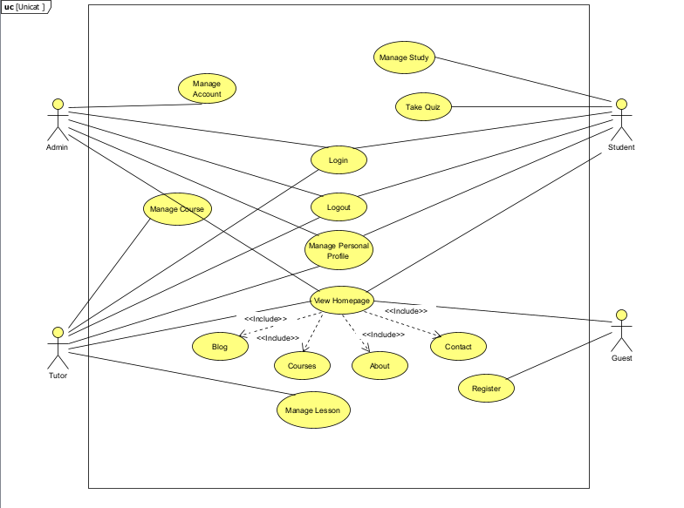

*Figure 2: High level use case diagram*

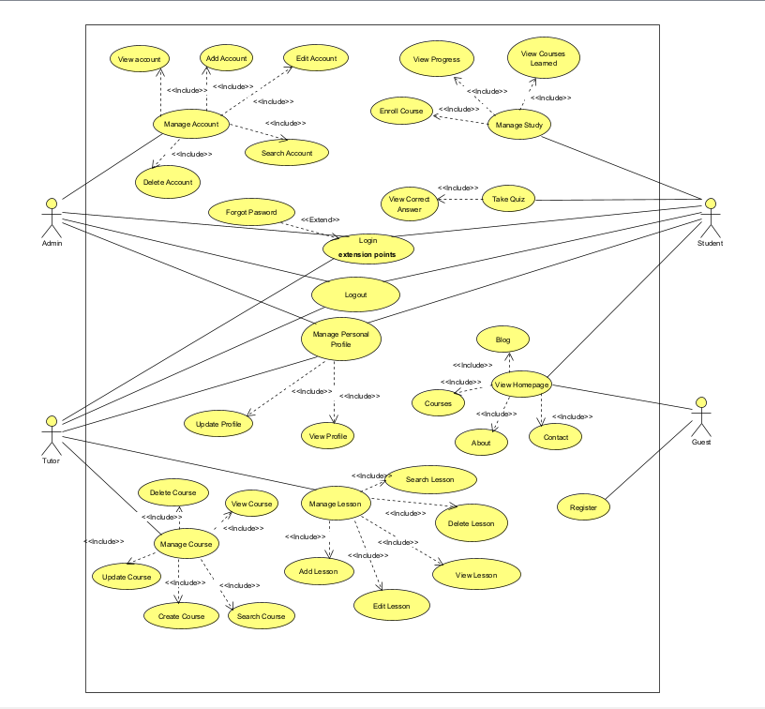

*Figure 3: Detailed use case diagram*

### ***2.2.2 Use Case Descriptions***

|  |  |  |  |
| --- | --- | --- | --- |
| **ID** | **Use Case** | **Actors** | **Use Case Description** |
| 01 | Manage Account | Admin | This function allows the admin to view all accounts in the system by clicking the account management button from the sidebar. |
| 02 | Add Account | Admin | This function allows the admin to add a new account into the system by clicking the “Add” button and filling out the form with account information. |
| 03 | View Account | Admin | This function allows the admin to view account information in the system by clicking on the view icon in the column on the account management page. |
| 04 | Edit Account | Admin | This function allows the admin to edit information of an account in the system by clicking on the edit icon on the column on the account management page. |
| 05 | Search Account | Admin | This function allows the admin to search an account by entering the name in the search box. |
| 06 | Delete Account | Admin | This function allows the admin to delete an account in the system by clicking the delete icon in the column on the account management page. |
| 07 | Manage Course | Tutor / Admin | This function allows the tutor or admin to view all courses in the system by clicking the course management button from the sidebar. |
| 08 | View Course | Tutor | This function allows the tutor to view course details in the system by clicking on the view icon in the column on the course management page. |
| 09 | Search Course | Tutor | This function allows the tutor to search a course by entering the name in the search box. |
| 10 | Create Course | Tutor | This function allows the tutor to create a new course into the system by clicking the “Create” button and filling out the form with course information. |
| 11 | Update Course | Tutor | This function allows the tutor to update information about a course in the system by clicking on the update icon on the column on the course management page. |
| 12 | Delete Course | Tutor | This function allows the tutor to delete a course in the system by clicking the delete icon in the column on the course management page. |
| 13 | Manage Lesson | Tutor | This function allows the tutor to view all lessons of a course in the system by clicking the lesson management button from the sidebar then clicking into course need to view. |
| 14 | Add Lesson | Tutor | This function allows the tutor to add a new lesson into the system by clicking the “Add” button and filling out the form with lesson information. |
| 15 | Search Lesson | Tutor | This function allows the tutor to search a lesson by entering the name in the search box. |
| 16 | Delete Lesson | Tutor | This function allows the tutor to delete a lesson in the system by clicking the delete icon in the column on the lesson management page. |
| 17 | View Lesson | Tutor | This function allows the tutor to view lesson details in the system by clicking on the view icon in the column on the lesson management page. |
| 18 | Edit Lesson | Tutor | This function allows the tutor to edit information about a lesson in the system by clicking on the edit icon on the column on the lesson management page. |
| 19 | Manage Study | Student | This function allows students to view study management navigation. |
| 20 | Enrol Course | Student | This function allows students to enrol in a course to study by clicking the “Enrol” button in the course details screen. |
| 21 | View Progress | Student | This function allows students to view study progress in the sidebar which includes all lesson titles. |
| 22 | View Courses Learned | Student | This function allows students to view all courses which they have learned in the user profile screen. |
| 23 | Take Quiz | Student | This function allows students to practise what they have just learned by pressing the “Take quiz” button on the screen and doing the exercises. |
| 24 | View Correct Answer | Student | This function allows students to view the correct answer when students finish all the quizzes by clicking the “Finish” button on the quiz screen. |
| 25 | Register | Guest | This function allows guests to register a new account in the system. |
| 26 | View Home Page | Student, Guest | This function allows students and guests to view Show sliders, hot posts, featured subjects, the sidebar with the latest posts, static contacts/links.Shown slider information includes its image and title, Shown latest Blog information includes its thumbnail, title, post-date, Shown top courses information includes its thumbnail, title, tag line, Shown all tutors information includes its thumbnail, title, tag line. |
| 27 | Blog | Student, Guest | This function allows students and guests to view all blogs with pagination. |
| 28 | Courses | Student, Guest | This function allows students and guests to view all Courses with pagination. |
| 29 | About | Student, Guest | This function allows students and guests to view everything they need to know about the “Unicat Online learning” Website. |
| 30 | Contact | Student, Guest | This function allows students and guests to view all Contacts about the website. |
| 31 | Login | Admin, Tutor, Student | This function allows actors to log into the system to access the functionality of the system. |
| 32 | Log out | Admin, Tutor, Student | This function allows actors to logout of the system. |
| 33 | Forgot Password | Admin, Tutor, Student | This function allows actors to change to a new password when having forgotten the password. |
| 34 | Manage Personal Profile | Admin, Tutor, Student | This function allows the actor to manage personal profile |
| 35 | Update Profile | Admin, Tutor, Student | This function allows actors to change personal information in the system by clicking the “Edit” button. |
| 36 | View Profile | Admin, Tutor, Student | This function allows the actor to view personal profile |
| 37 | Quiz Manager | Tutor | This function allows the tutor or admin to view all quizzes in the system by clicking the Quiz management button from the sidebar. |
| 38 | View Quiz | Tutor | This function allows the tutor to view quiz details in the system by clicking on the view icon in the column on the quiz management page. |
| 39 | Create Quiz | Tutor | This function allows the tutor to create a new quiz into the system by clicking the “Create” button and filling out the form with quiz information. |
| 40 | Search Quiz | Tutor | This function allows the tutor to search a quiz by entering the name in the search box. |
| 41 | Update Quiz | Tutor | This function allows the tutor to update information about a quiz in the system by clicking on the update icon on the column on the quiz management page. |
| 42 | Delete Quiz | Tutor | This function allows the tutor to delete a quiz in the system by clicking the delete icon in the column on the quiz management page. |
| 43 | Add Quiz | Tutor | This function allows the tutor to add a new quiz into the system by clicking the “Add” button and filling out the form with quiz information. |
| 44 | Answer Manager | Tutor | This function allows the tutor or admin to view all answers in the system by clicking the Answer management button from the sidebar. |
| 45 | View Answer | Tutor | This function allows the tutor to view answer details in the system by clicking on the view icon in the column on the answer management page. |
| 46 | Create Answer | Tutor | This function allows the tutor to create a new answer into the system by clicking the “Create” button and filling out the form with answer information. |
| 47 | Search Answer | Tutor | This function allows the tutor to search for an answer by entering the name in the search box. |
| 48 | Update Answer | Tutor | This function allows the tutor to update information about an answer in the system by clicking on the update icon on the column on the answer management page. |
| 49 | Delete Answer | Tutor | This function allows the tutor to delete an answer in the system by clicking the delete icon in the column on the answer management page. |
| 50 | Add Answer | Tutor | This function allows the tutor to add a new answer into the system by clicking the “Add” button and filling out the form with answer information. |
| 51 | Request Publish,  Un-Publish | Tutor | This function allows tutor to send request to admin to accept request of course to publish ỏ unpublish to update course |
| 52 | Accept Request,  Cancel Request | Admin | This function allows Admin to accept or cancel request publish or unpublish from tutor’s request |

*Table 2: Use Case list and description*

# *3. Functional Requirements*

## *3.1 System Functional Overview*

### ***3.1.1 Screen Flow***

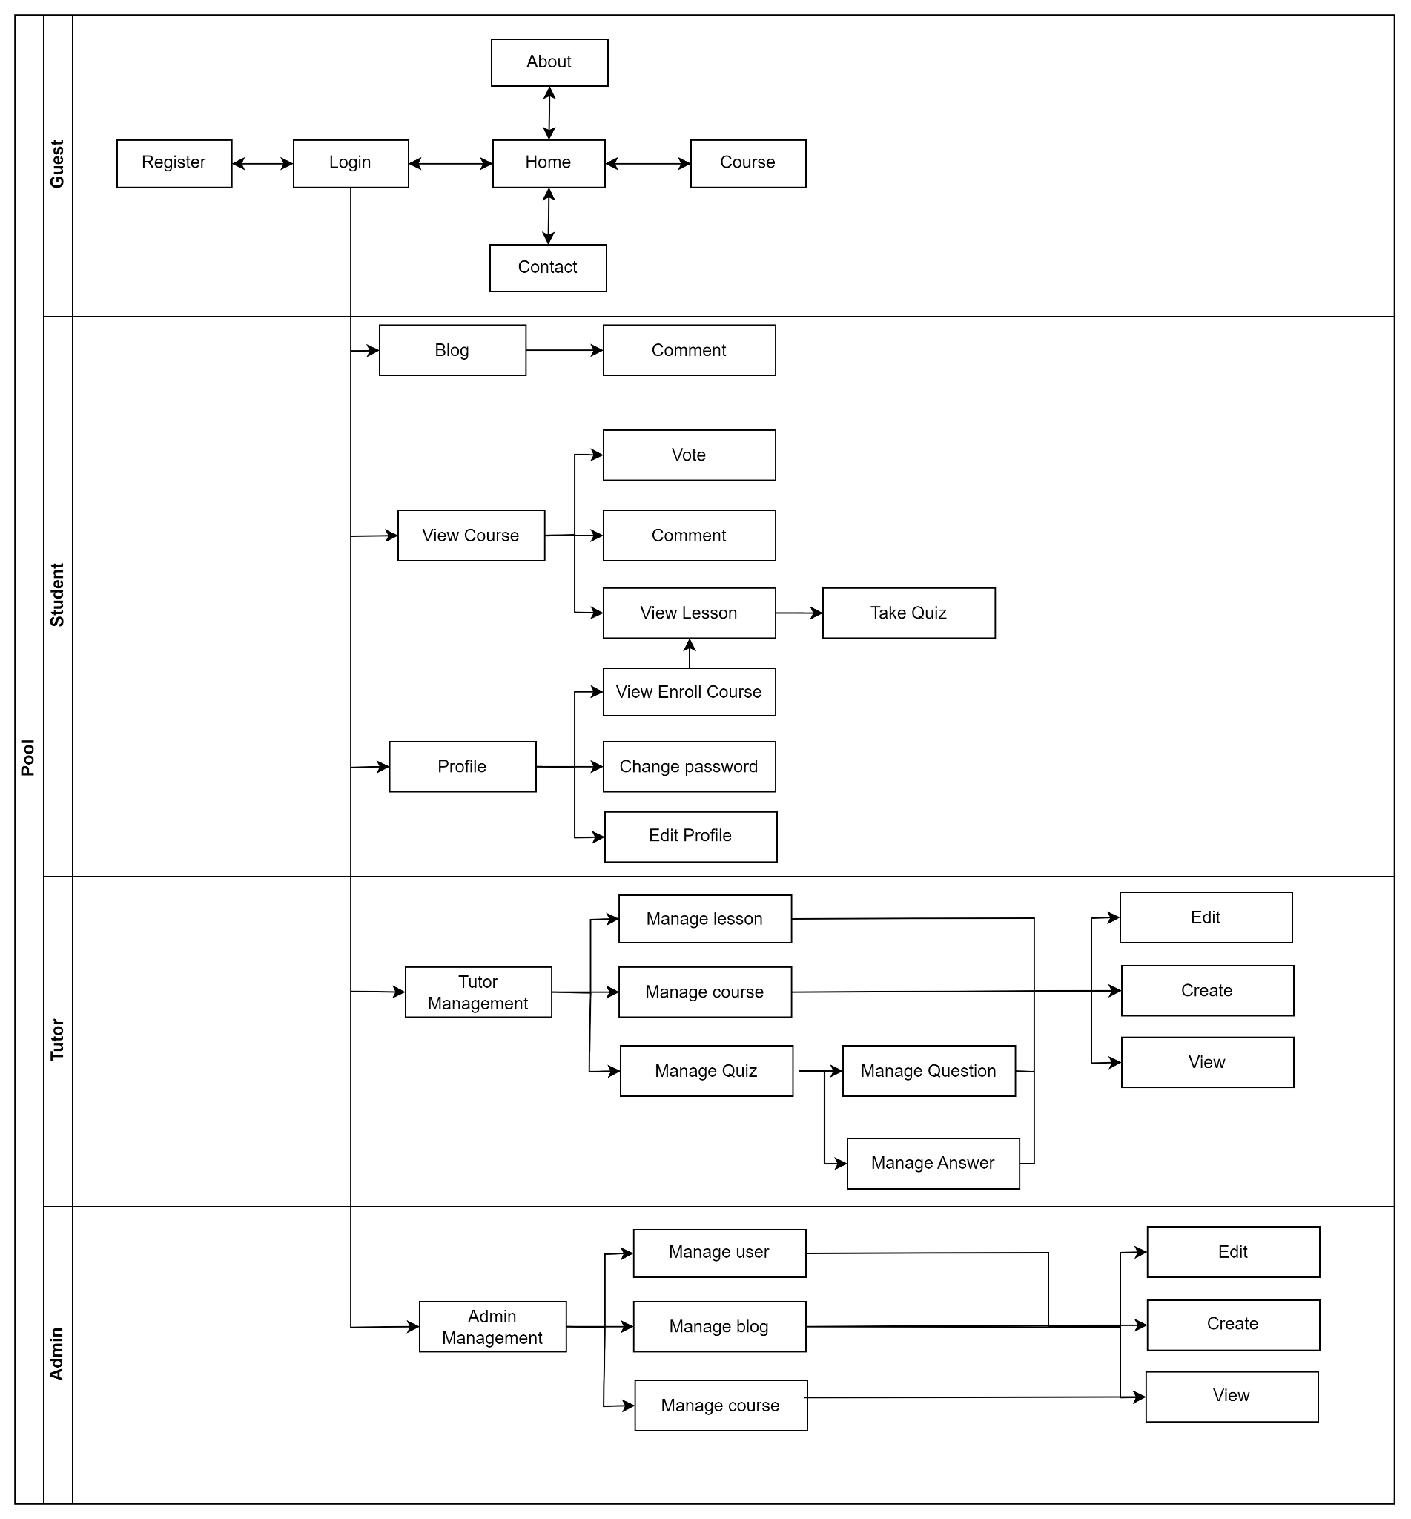

*Figure 4: Screen flow Diagram*

### ***3.1.2 Screen Description***

|  |  |  |  |
| --- | --- | --- | --- |
| **#** | **Feature** | **Screen** | **Description** |
| 1 | Manage account | Manage account | Display all accounts in the system |
| 2 | Manage account | Edit account | Display pop-up form with account information to change user’s status, user’s role |
| 3 | Manage account | Search account | Display a list of accounts that contains keywords |
| 4 | Manage account | Delete account | Display confirmation message to delete an account in the system |
| 5 | Manage account | View account | Display account information |
| 6 | Manage account | Add account | Display pop-up form to add a new account into the system |
| 7 | Manage Personal Profile | Enrol Course | Display course has been enrolled |
| 8 | Manage Personal Profile | View Courses learned | Display course that has been fully learned |
| 9 | Manage Personal Profile | View progress | Display user’s learning progress in each course |
| 10 | Manage Personal Profile | Update profile | Display form to change user information |
| 11 | Manage Personal Profile | Manage profile information | Display user's information to update |
| 12 | Manage lesson | Display results | Display score, number of questions students answered correctly |
| 13 | Manage lesson | Take quiz | Display questions according to student settings |
| 14 | Manage lesson | View lesson | Display lesson information |
| 15 | Manage lesson | Search lesson | Display a list of lessons that contains keywords |
| 16 | Manage lesson | Delete lesson | Display confirmation message to delete a lesson in the system |
| 17 | Manage lesson | Edit lesson | Display form to change lesson information |
| 18 | Manage lesson | Add lesson | Display pop-up form to add a new lesson into the system |
| 19 | Manage course | Search course | Display a list of courses that contains keywords |
| 20 | Manage course | Delete course | Display confirmation message to delete a course in the system |
| 21 | Manage course | Update course | Display form to change course information |
| 22 | Manage course | Add course | Display pop-up form to add a new course into the system |
| 23 | Manage blog | Add blog | Display pop-up form to add a new blog into the system |
| 24 | Manage blog | Delete blog | Display confirmation message to delete a blog in the system |
| 25 | Manage blog | Update blog | Display form to change blog information |
| 26 | Manage blog | Search blog | Display a list of blogs that contains keywords |
| 27 | Common | Register | Register an account for a new user |
| 28 | Common | Login | Allow users to log in to use services |
| 29 | Common | Homepage | Main functionally page for user |
| 30 | Common | Forgot Password | Allow users to input email to receive forgot password link |
| 31 | Common | View blog | Everyone can see and interact blog such as comment but guest only can view blogs |
| 32 | Common | View course | Everyone can see and interact course such as comment but guest only can view courses |
| 33 | Common | View About | Display About (Everything need to know about the website) information |
| 34 | Common | View Contact | Display Contact information (social media, address, phone number) |

*Table 3: Screen description*

### ***3.1.3 Screen Authorization***

|  |  |  |  |  |
| --- | --- | --- | --- | --- |
| **Screen** | **Admin** | **Tutor** | **Student** | **Guest** |
| Manage Account | X |  |  |  |
| Edit Account | X |  |  |  |
| Add Account | X |  |  |  |
| Delete Account | X |  |  |  |
| View Account | X |  |  |  |
| Search Account | X |  |  |  |
| Enrol Course | X |  | X |  |
| View Courses learned | X |  | X |  |
| View progress |  |  | X |  |
| Update profile |  |  | X |  |
| Manage profile information |  |  | X |  |
| Display results |  |  | X |  |
| Take quiz |  |  | X |  |
| View lesson |  |  | X |  |
| Search lesson |  | X |  |  |
| Delete lesson |  | X |  |  |
| Edit lesson |  | X |  |  |
| Add lesson |  | X |  |  |
| View course | X | X | X | X |
| Search course | X | X | X | X |
| Delete course |  | X |  |  |
| Update course |  | X |  |  |
| Add course |  | X |  |  |
| View blog | X | X | X | X |
| Add blog | X |  |  |  |
| Delete blog | X |  |  |  |
| Update blog | X |  |  |  |
| Search blog | X | X | X | X |
| Register |  |  |  | X |
| Login | X | X | X |  |
| Homepage | X | X | X | X |
| Forgot Password | X | X | X |  |
| View About | X | X | X | X |
| View Contact | X | X | X | X |
| Send Publish and Unpublish Request |  | X |  |  |
| Cancel Request | X | X |  |  |
| Accept Request | X |  |  |  |

*Table 4: Screen Authorization*

### 

### ***3.1.4 Entity Relationship Diagram***

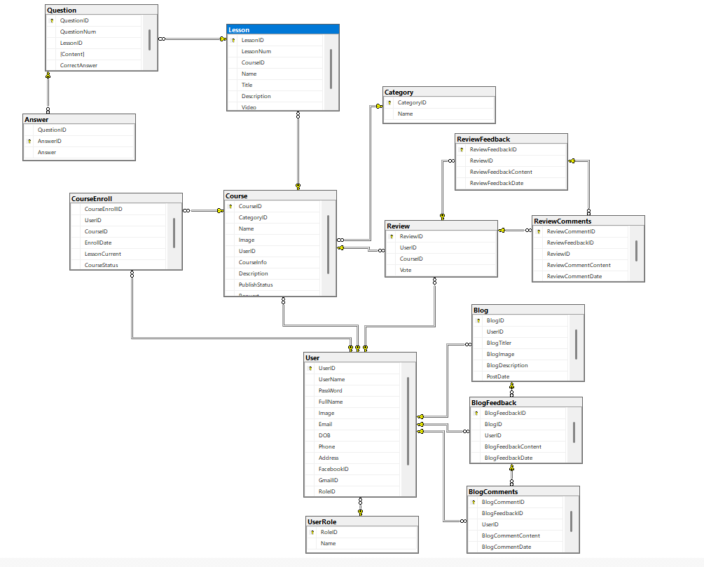

## *3.2 Admin:*

### ***3.2.1 User Manager***

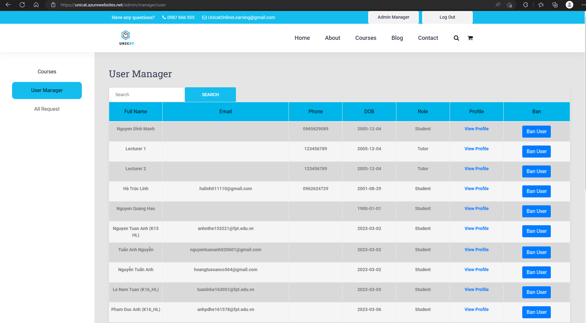

*Figure 5: User Manager Screen*

|  |  |  |  |  |
| --- | --- | --- | --- | --- |
| **ID and Name** | **01 - User Manager** | | **Actor** | Admin |
| **Description** | This page is for admin to manage users like display user information, search for users, view profiles of users, delete users. | | | |
| **Trigger** | /admin/manager/user | | | |
| **Preconditions** | **PRE-1.**Actor has logged in the system with an admin account. | | | |
| **Post-conditions** | **POST-1.** The system displays the user list. | | | |
| **Normal Flows** | **Actor actions** | **System responses** | | |
| 1.Actor clicks a “Admin Manager” button on the screen. | 2.Display all the users (Tutor and Student). | | |
| **Alternative Flows** | Actors can click a “User manager” button on the side bar. | | | |
| **Exception Flows** | **N/A** | | | |
| **Business Rules** | **BR-01** | | | |

### ***3.2.2 Course Manager***

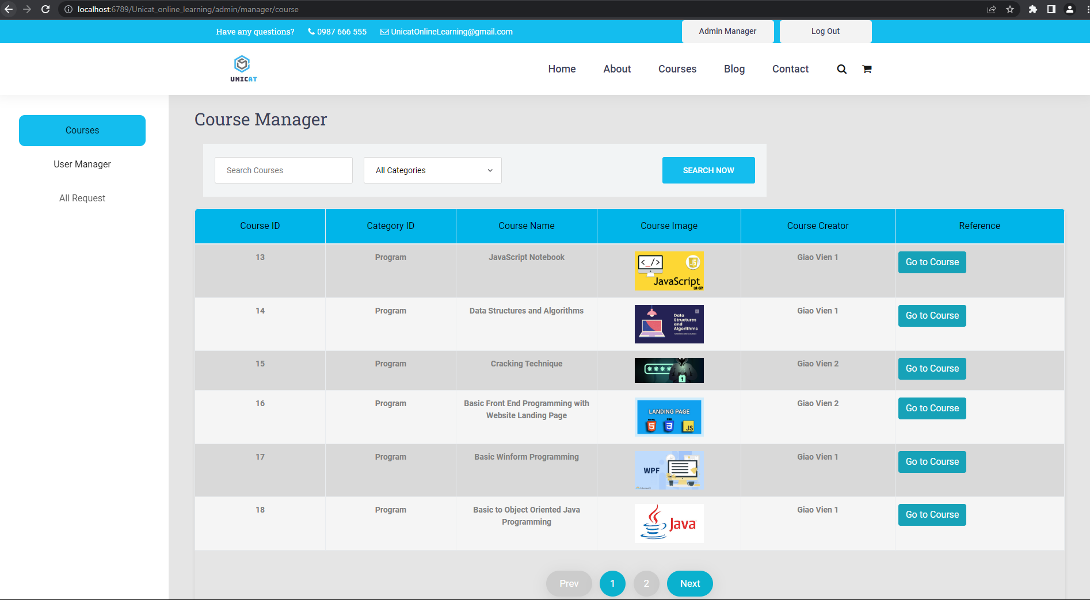

*Figure 6: Course Manager Screen*

|  |  |  |  |  |
| --- | --- | --- | --- | --- |
| **ID and Name** | **02 - Published Course Manager** | | **Actor** | Admin |
| **Description** | This page is for admin to manage users like display course information, search for courses, view profiles of courses | | | |
| **Trigger** | /admin/manager/course | | | |
| **Preconditions** | **PRE-1.**Actor has logged in the system with an admin account. | | | |
| **Post-conditions** | **POST-1.** The system displays the course list. | | | |
| **Normal Flows** | **Actor actions** | **System responses** | | |
| 1.Actor clicks a “Admin Manager” button on the screen. | 2.Display all the published courses of all tutors. | | |
| **Alternative Flows** | Actors can click a “Courses” button on the side bar. | | | |
| **Exception Flows** | **N/A** | | | |
| **Business Rules** | **BR-01** | | | |

### ***3.2.3 Course Request Manager***

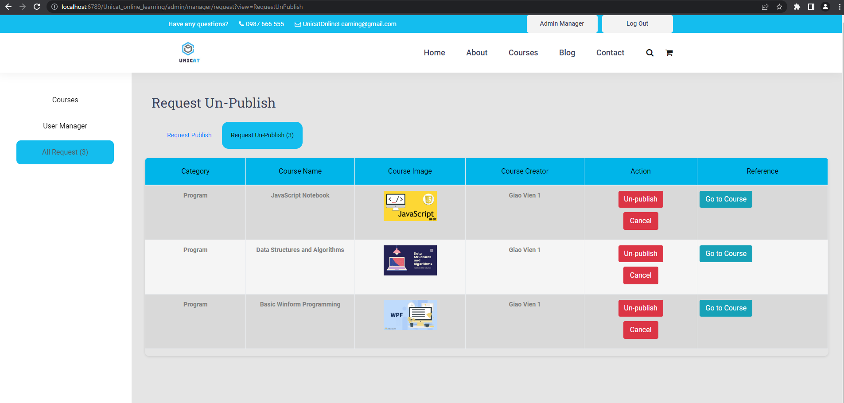

*Figure 7: Course Manager Screen*

|  |  |  |  |  |
| --- | --- | --- | --- | --- |
| **ID and Name** | **03 - Requested Course Manager** | | **Actor** | Admin |
| **Description** | This page is for admin to manage users like display course request information, view profiles of courses, user can publish or unpublish or cancel the request courses. | | | |
| **Trigger** | /admin/manager/request | | | |
| **Preconditions** | **PRE-1.**Actor has logged in the system with an admin account. | | | |
| **Post-conditions** | **POST-1.** The system displays the request course list. | | | |
| **Normal Flows** | **Actor actions** | **System responses** | | |
| 1.Actor clicks a “Admin Manager” button on the screen.  3.Actor clicks a “All Request” button on the sidebar. | 2.Display all the published courses of all tutors.  4.Display all the requested (publish or unpublish) courses of the tutor. | | |
| **Alternative Flows** | **N/A** | | | |
| **Exception Flows** | **N/A** | | | |
| **Business Rules** | **BR-01** | | | |

## *3.3 Tutor*

### ***3.3.1 Course Manager***

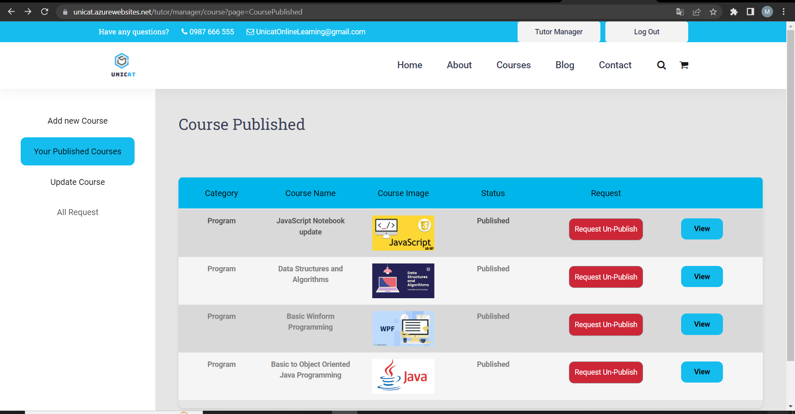

*Figure 8: Course Manager Screen*

|  |  |  |  |  |
| --- | --- | --- | --- | --- |
| **ID and Name** | **04 - Published Course Manager** | | **Actor** | Tutor |
| **Description** | This page provides a service for the tutor to manage all courses published of the user such as previewing courses, moderating a new course after the tutor adds it to the course list, users can request a course from the admin. | | | |
| **Trigger** | /tutor/manager/course?page=CoursePublished | | | |
| **Preconditions** | **PRE-1.** Actor has logged in the system with an admin account. | | | |
| **Post-conditions** | **POST-1.** The system displays the course list. | | | |
| **Normal Flows** | **Actor actions** | **System responses** | | |
| 1.Actor click a “Tutor Manager” button on the screen | 2. Display screen management with a list of published courses. | | |
| **Alternative Flows** | **N/A** | | | |
| **Exception Flows** | **N/A** | | | |
| **Business Rules** | **BR-01** | | | |

### ***3.3.2 Add Course***

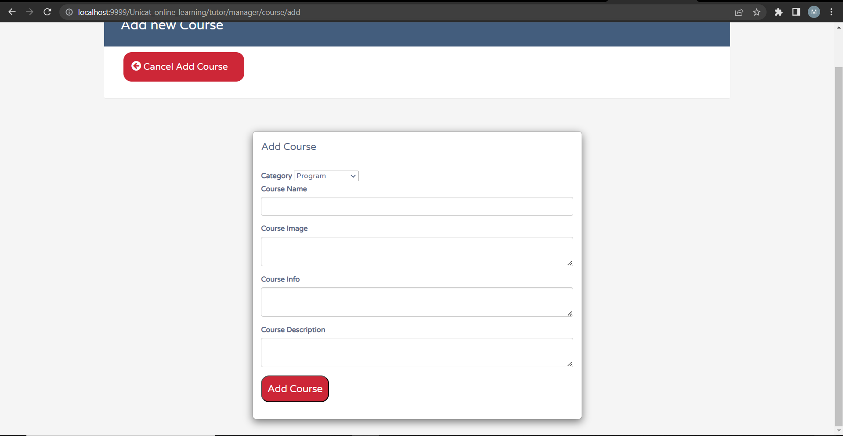

*Figure 9: Add Course Screen*

|  |  |  |  |  |
| --- | --- | --- | --- | --- |
| **ID and Name** | **05 - Add Course** | | **Actor** | Tutor |
| **Description** | This page provides a service for the tutor to add courses. | | | |
| **Trigger** | /tutor/manager/course/add | | | |
| **Preconditions** | **PRE-1.** Actor has logged in the system with a tutor account. | | | |
| **Post-conditions** |  | | | |
| **Normal Flows** | **Actor actions** | **System responses** | | |
| 1.Actor click a “Tutor Manager” button on the screen  3.Actor clicks a “Add Course” button on the sidebar. | 1. System add new course into database 2. Display add course screen. | | |
| **Alternative Flows** | **N/A** | | | |
| **Exception Flows** | **N/A** | | | |
| **Business Rules** | **BR-01, BR-03** | | | |

### ***3.3.3 Update Course Manager***

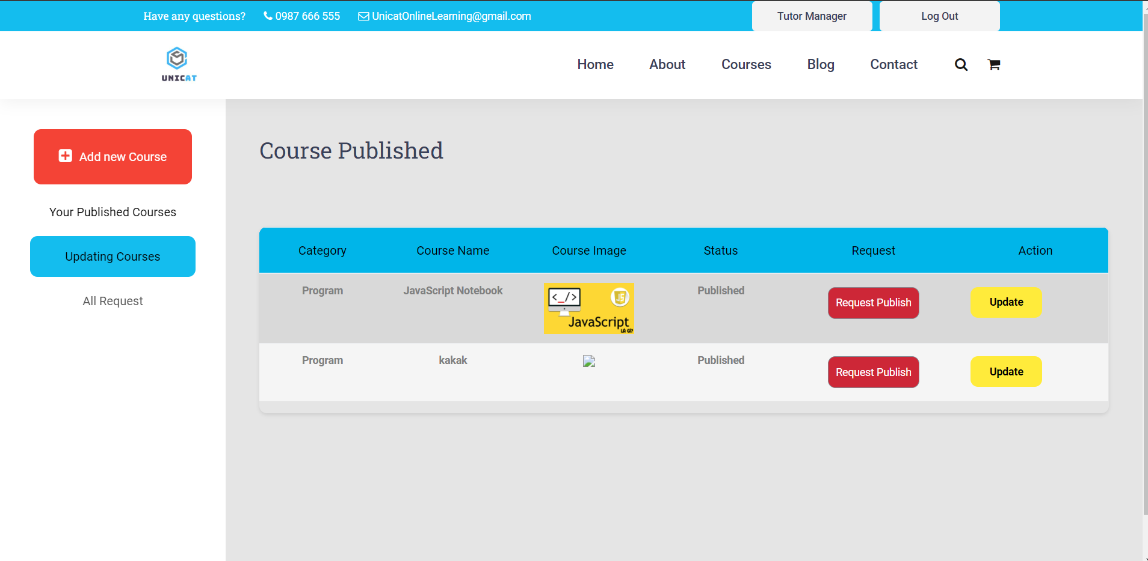

*Figure 10: Update Course Manager Screen*

|  |  |  |  |  |
| --- | --- | --- | --- | --- |
| **ID and Name** | **06 - Update Course Manager** | | **Actor** | Tutor |
| **Description** | This page provides a service for the tutor to manage all courses in update courses of the user such as previewing courses, moderating a new course after the tutor adds it to the course list. | | | |
| **Trigger** | /tutor/manager/course?page=UpdatingCourse | | | |
| **Preconditions** | **PRE-1.** Actor has logged in the system with an admin account. | | | |
| **Post-conditions** | **POST-1.** The system displays the updated course list. | | | |
| **Normal Flows** | **Actor actions** | **System responses** | | |
| 1.Actor click a “Tutor Manager” button on the screen  3.Actor clicks a “Update Course” button on the sidebar. | 2. Display screen management with a list of published courses. | | |
| **Alternative Flows** | **N/A** | | | |
| **Exception Flows** | **N/A** | | | |
| **Business Rules** | **BR-01** | | | |

### ***3.3.4 Request Course Manager***

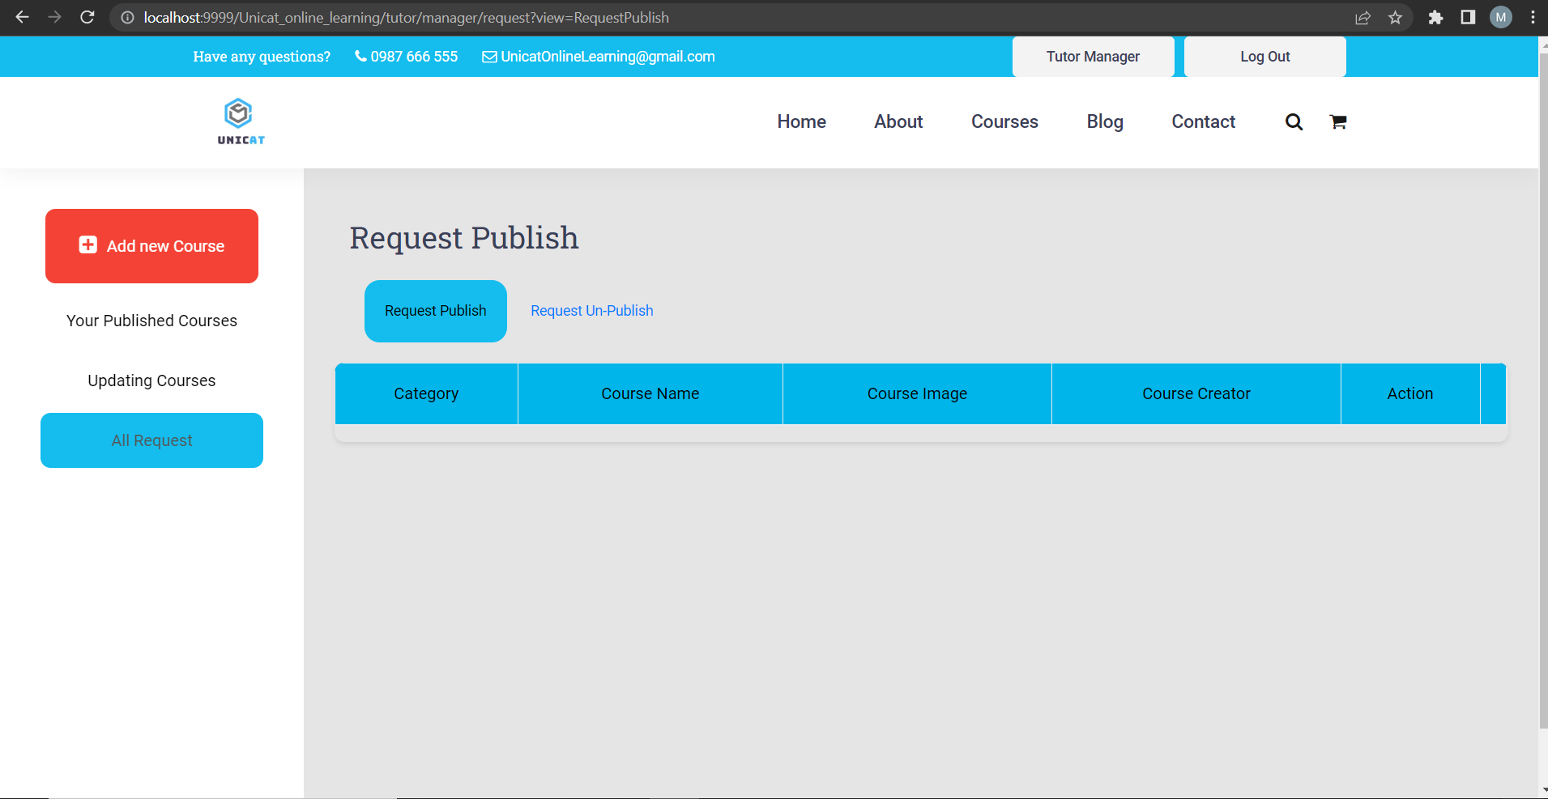

*Figure 11: Requested Course Manager Screen*

|  |  |  |  |  |
| --- | --- | --- | --- | --- |
| **ID and Name** | **07 - Request Course Manager** | | **Actor** | Tutor |
| **Description** | This page provides a service for the tutor to manage all requested courses until the admin accepts it to the course list or cancels it. | | | |
| **Trigger** | /tutor/manager/request?view=Request | | | |
| **Preconditions** | **PRE-1.** Actor has logged in the system with an admin account. | | | |
| **Post-conditions** | **POST-1.** The system displays the requested course list. | | | |
| **Normal Flows** | **Actor actions** | **System responses** | | |
| 1.Actor click a “Tutor Manager” button on the screen  3.Actor clicks a “All Request” button on the sidebar. | 2. Display screen management with a list of published courses. | | |
| **Alternative Flows** | **N/A** | | | |
| **Exception Flows** | **N/A** | | | |
| **Business Rules** | **BR-01** | | | |

### ***3.3.5 Add,Delete,Update Lesson***

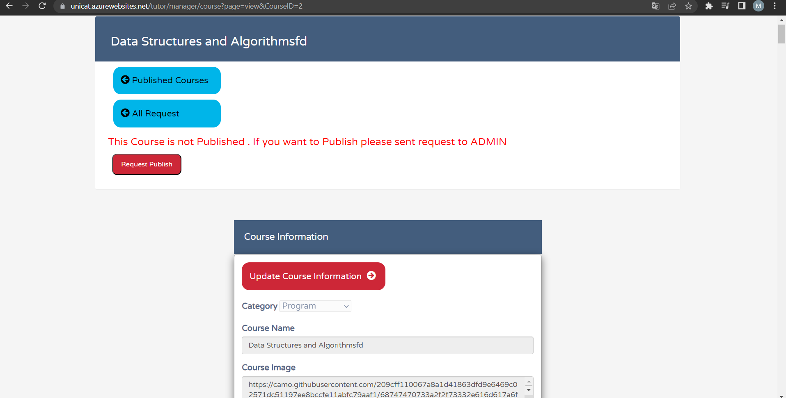

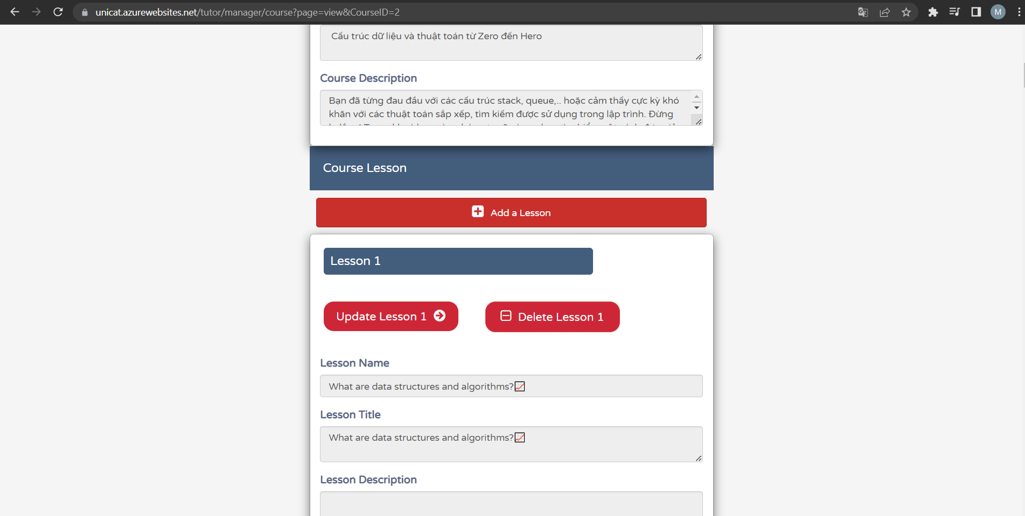

|  |  |  |  |  |
| --- | --- | --- | --- | --- |
| **ID and Name** | **08 - Lesson Manager** | | **Actor** | Tutor |
| **Description** | This function allows the tutor to add ,delete or update lesson of course that they created | | | |
| **Trigger** | /tutor/manager/course?page=view&CourseID= | | | |
| **Preconditions** | **User sign with a tutor account and in Tutor Manager page** | | | |
| **Post-conditions** | **Request back to update course page** | | | |
| **Normal Flows** | **Actor actions** | **System responses** | | |
| 1.Login into admin or tutor account, click ‘All Request’ | 1. Update , add,delete lesson with database | | |
| **Alternative Flows** | **N/A** | | | |
| **Exception Flows** | **N/A** | | | |
| **Business Rules** | **N/A** | | | |

## *3.4 User*

### ***3.4.1 Profile Manager***

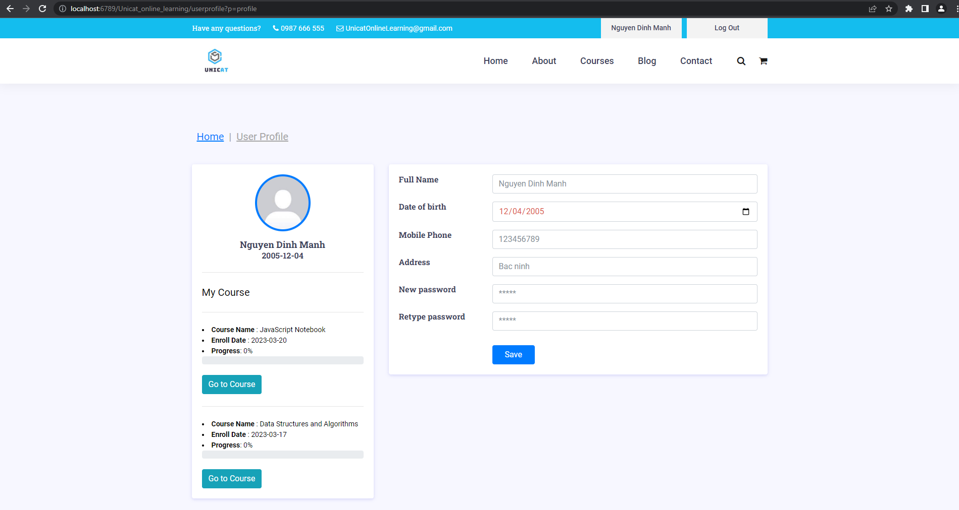

*Figure 12: Profile Manager Screen*

|  |  |  |  |  |
| --- | --- | --- | --- | --- |
| **ID and Name:** | **08 - Profile Manager** | | **Actor** | Student |
| **Description:** | This page provides all current user’s information such as full name, avatar, date of birth, phone number, address and all current courses have done or are in learning progress. | | | |
| **Trigger** | /userprofile?p=profile | | | |
| **Preconditions** | **PRE-1.** Actor has logged in the system with an admin account. | | | |
| **Post-conditions** | **POST-1.** The system displays the course list. | | | |
| **Normal Flows** | **Actor actions** | **System responses** | | |
| 1.Actor clicks the name of the user button on the top of the screen. | 2. Display profile screen management. | | |
| **Alternative Flows** | **N/A** | | | |
| **Exception Flows** | **N/A** | | | |
| **Business Rules:** | **BR-01, BR-02** | | | |

### ***3.4.2 Lesson Details Screen***

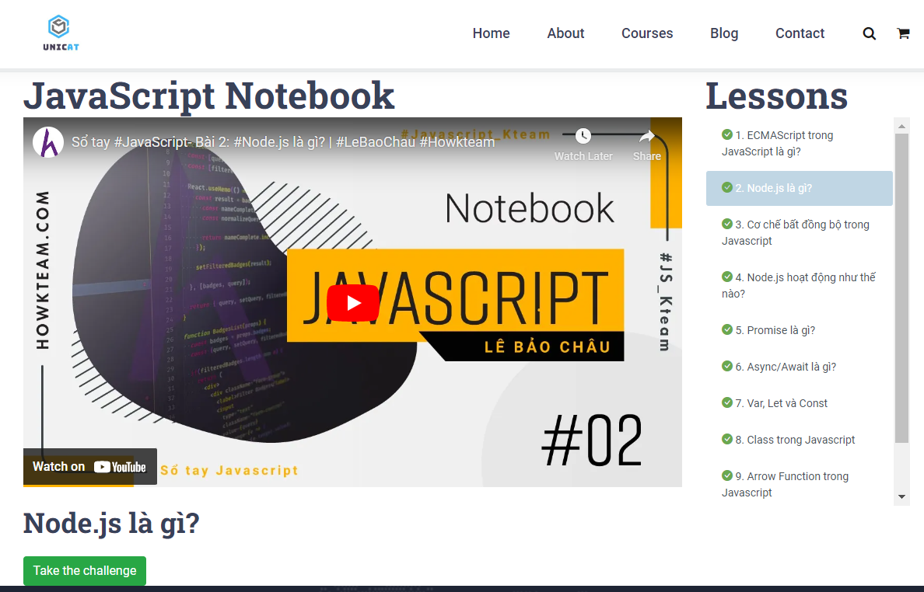

|  |  |  |  |  |
| --- | --- | --- | --- | --- |
| **ID and Name:** | **09 - *Lesson Details*** | | **Actor** | Student |
| **Description:** | This page provides all materials of a course for students to learn and take a quiz. | | | |
| **Trigger** | /LessonDetail | | | |
| **Preconditions** | **PRE-1.** Actor has logged in the system with an student account. | | | |
| **Post-conditions** | **POST-1.** The system displays the lesson list. | | | |
| **Normal Flows** | **Actor actions** | **System responses** | | |
| 1.Actor clicks the name of course in the courses screen | 2. Display all lessons of course including content and video. | | |
| **Alternative Flows** | **N/A** | | | |
| **Exception Flows** | **N/A** | | | |
| **Business Rules:** | **BR-01, BR-02** | | | |

### ***3.4.3 Quiz Screen***

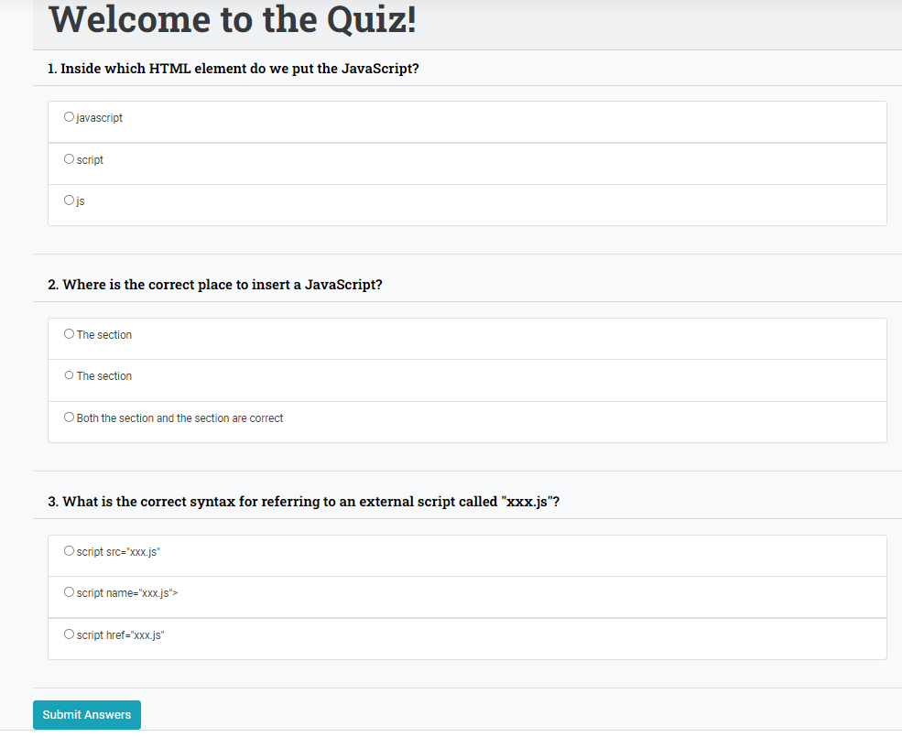

|  |  |  |  |  |
| --- | --- | --- | --- | --- |
| **ID and Name:** | **10 - *Quiz Screen*** | | **Actor** | Student |
| **Description:** | This page provides all questions of a lesson | | | |
| **Trigger** | /Quiz | | | |
| **Preconditions** | **PRE-1.** Actor has logged in the system with a student account. | | | |
| **Post-conditions** | **POST-1.** The system displays the course list. | | | |
| **Normal Flows** | **Actor actions** | **System responses** | | |
| 1.Actor clicks the “Take the challenge” button in Lesson Details Screen | 2. Display all quiz of lesson following multiple choice format. | | |
| **Alternative Flows** | **N/A** | | | |
| **Exception Flows** | **N/A** | | | |
| **Business Rules:** | **BR-01, BR-02** | | | |

## *3.5 Common feature*

### ***3.5.1 About***

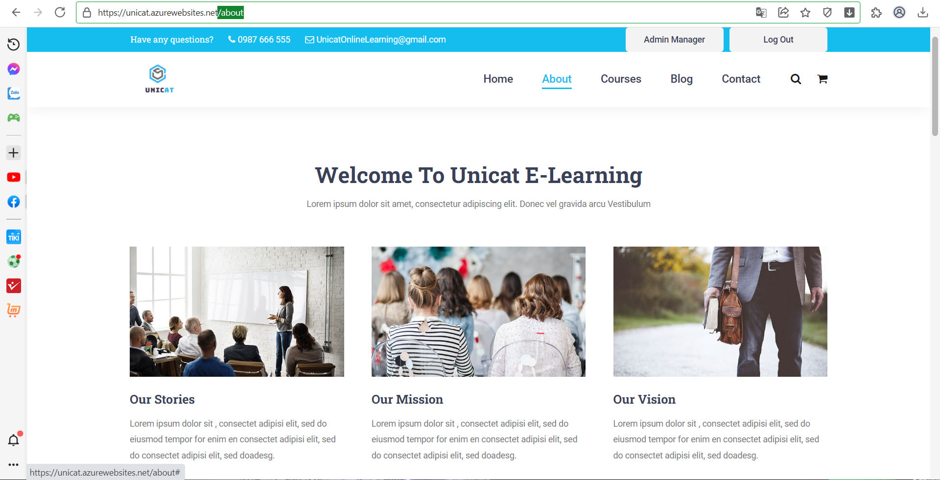

*Figure 13: About Screen*

|  |  |  |  |  |
| --- | --- | --- | --- | --- |
| **ID and Name** | **09 - About** | | **Actor** | Student, Guest, Student, Admin |
| **Description** | This function allows all actors to view everything they need to know about the “Unicat Online learning” Website. | | | |
| **Trigger** | /about | | | |
| **Preconditions** | **N/A** | | | |
| **Post-conditions** | **POST-1.** The system displays the “About” information | | | |
| **Normal Flows** | **Actor actions** | **System responses** | | |
| 1.Actor clicks the “About” button on the top of the screen. | 2. Display About screen profile. | | |
| **Alternative Flows** | **N/A** | | | |
| **Exception Flows** | **N/A** | | | |
| **Business Rules** | **N/A** | | | |

### ***3.5.2 Homepage***

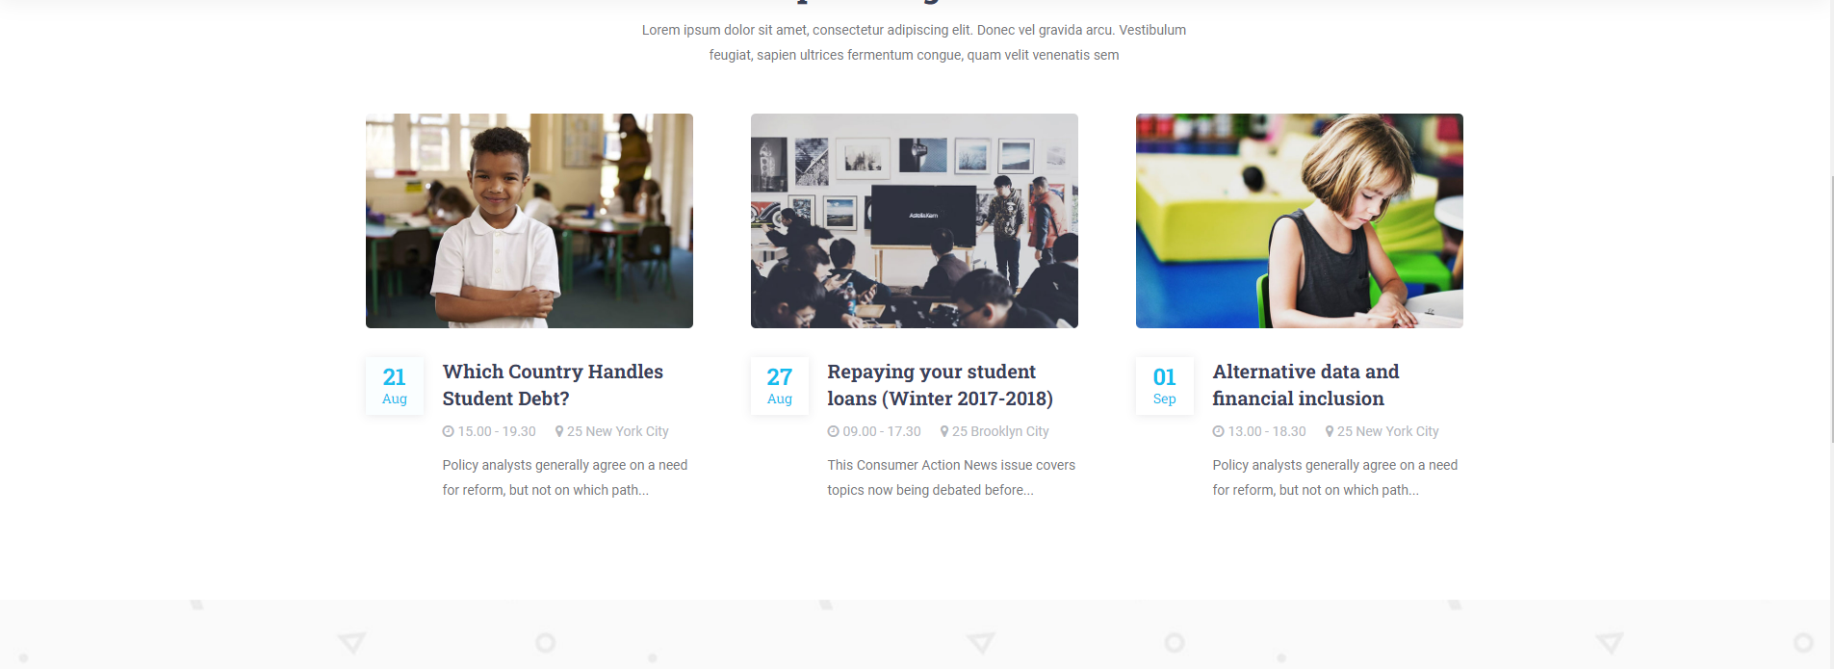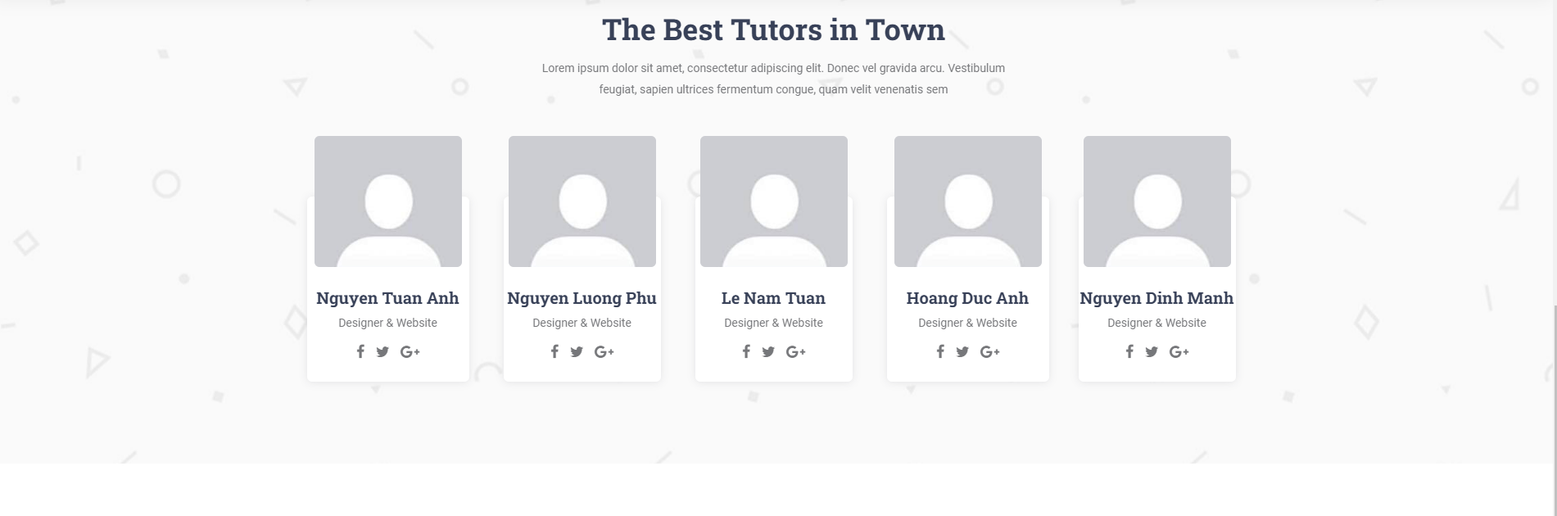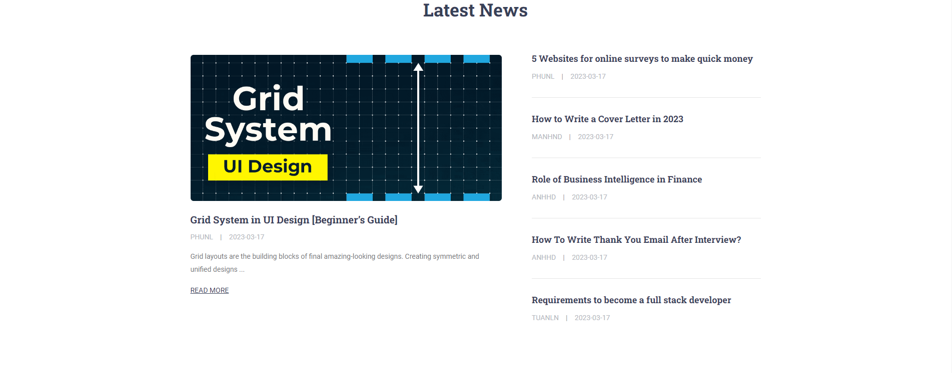

*Figure 14: Home Screen*

|  |  |  |  |  |
| --- | --- | --- | --- | --- |
| **ID and Name** | **10 - Home** | | **Actor** | Student, Guest, Student, Admin |
| **Description** | This function allows all actors on the main function page for the user. | | | |
| **Trigger** | /home | | | |
| **Preconditions** | **N/A** | | | |
| **Post-conditions** | **POST-1.** The system display all the informations following popular course, all admins and latest blogs | | | |
| **Normal Flows** | **Actor actions** | **System responses** | | |
| 1.Actor clicks the “Home” button on the top of the screen. | 2. Display Home screen profile. | | |
| **Alternative Flows** | **N/A** | | | |
| **Exception Flows** | **N/A** | | | |
| **Business Rules** | **N/A** | | | |

### ***3.5.3. Blog***

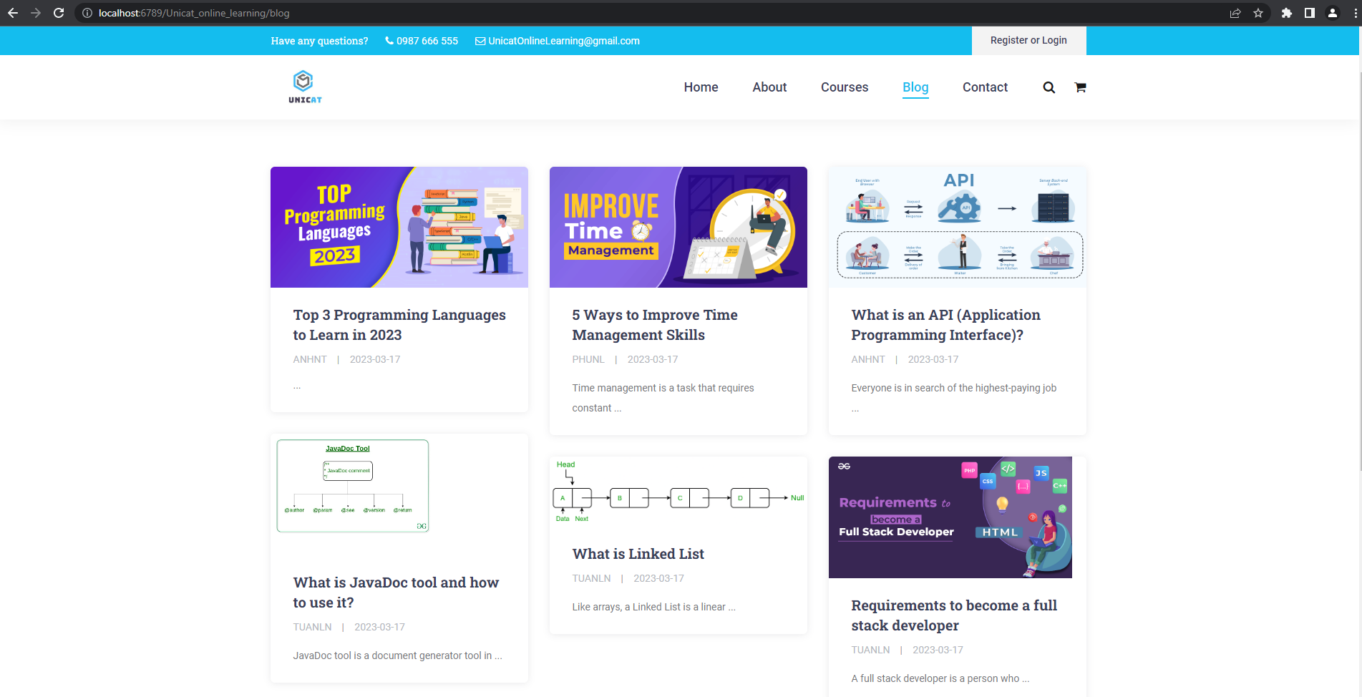

*Figure 15: Blog Screen*

|  |  |  |  |  |
| --- | --- | --- | --- | --- |
| **ID and Name** | **11 - Blog** | | **Actor** | Student, Guest, Student, Admin |
| **Description** | This function allows students and guests to view all blogs with pagination. | | | |
| **Trigger** | /blog | | | |
| **Preconditions** | **N/A** | | | |
| **Post-conditions** | **POST-1.** The system display all the informations fa about | | | |
| **Normal Flows** | **Actor actions** | **System responses** | | |
| 1.Actor clicks the “Blog” button on the top of the screen. | 2. Display all Blog lists. | | |
| **Alternative Flows** | **N/A** | | | |
| **Exception Flows** | **N/A** | | | |
| **Business Rules** | **N/A** | | | |

### ***3.5.4 Contact***

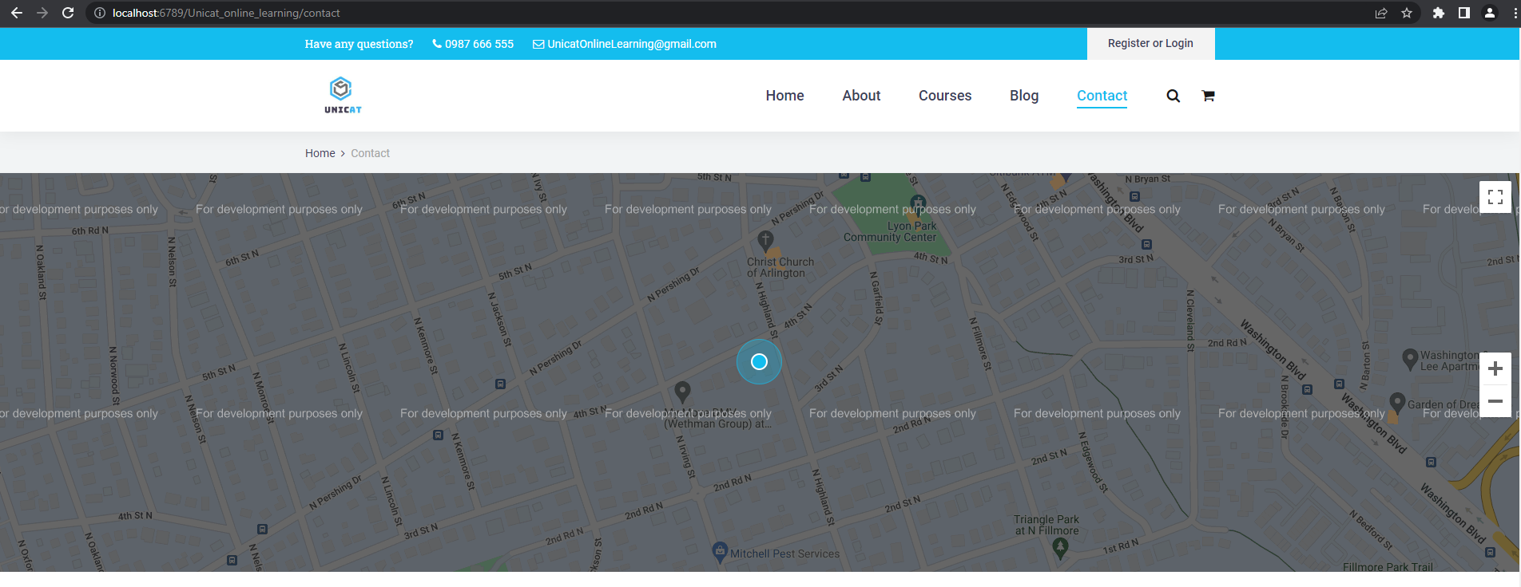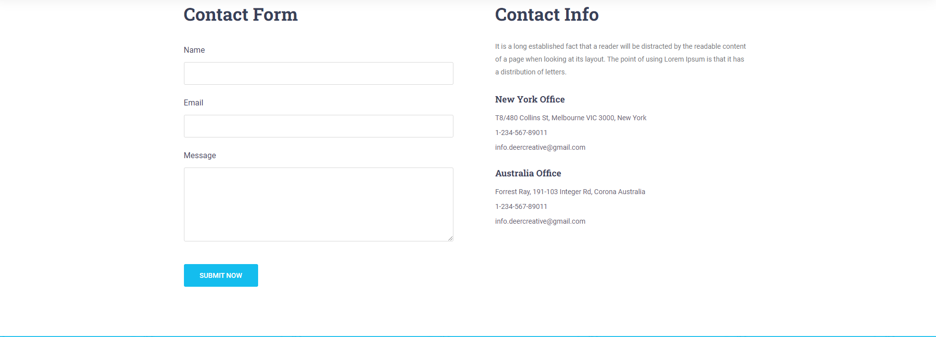

*Figure 16: Contact Screen*

|  |  |  |  |  |
| --- | --- | --- | --- | --- |
| **ID and Name** | **12 - Contact** | | **Actor** | Student, Guest, Student, Admin |
| **Description** | This function allows students and guests to view all Contacts about the website. | | | |
| **Trigger** | /Contact | | | |
| **Preconditions** | **N/A** | | | |
| **Post-conditions** | **N/A** | | | |
| **Normal Flows** | **Actor actions** | **System responses** | | |
| 1.Actor clicks the “Contact” button on the top of the screen. | 2. Display all Contact. | | |
| **Alternative Flows** | **N/A** | | | |
| **Exception Flows** | **N/A** | | | |
| **Business Rules** | **N/A** | | | |

### ***3.5.5 Courses***

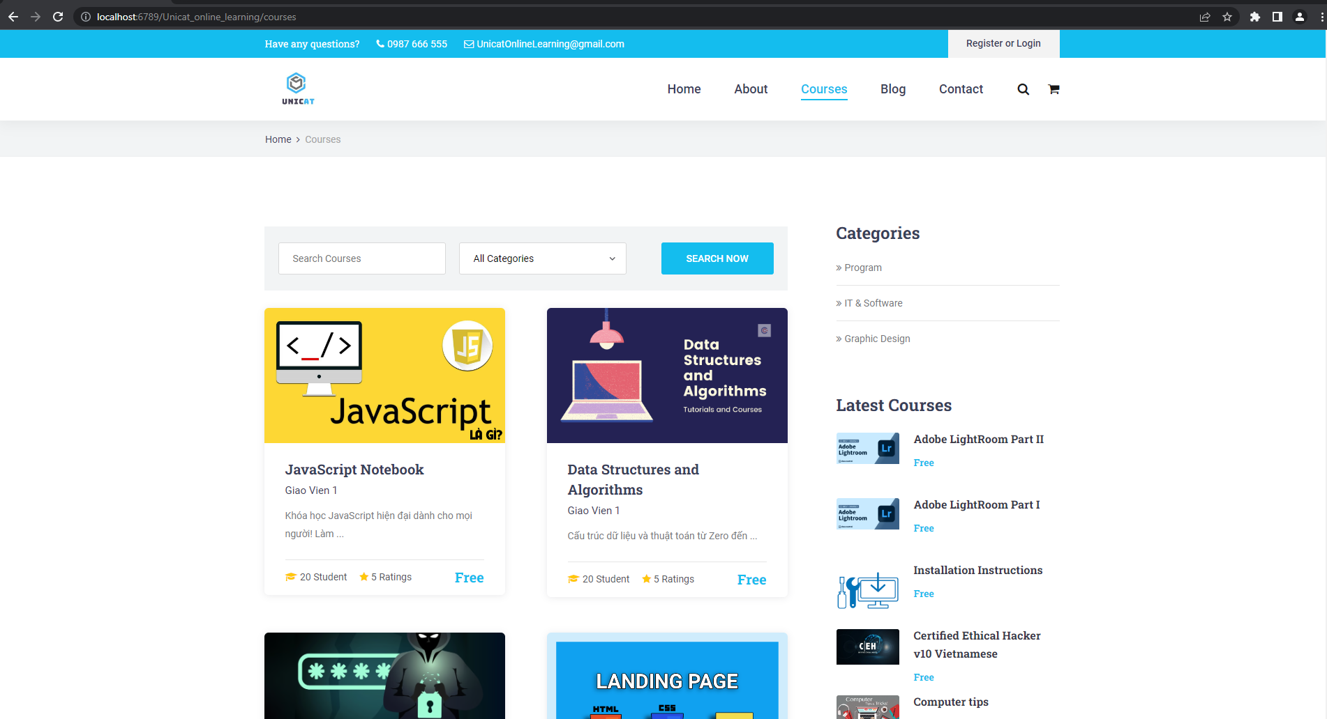

*Figure 17: Courses Screen*

|  |  |  |  |  |
| --- | --- | --- | --- | --- |
| **ID and Name** | **13 - Courses** | | **Actor** | Student, Guest, Student, Admin |
| **Description** | This function allows everyone to view and interact with courses such as comments but guests can only view courses. | | | |
| **Trigger** | /courses | | | |
| **Preconditions** | **N/A** | | | |
| **Post-conditions** | **N/A** | | | |
| **Normal Flows** | **Actor actions** | **System responses** | | |
| 1.Actor clicks the “Courses” button on the top of the screen. | 2. Display all the published Courses. | | |
| **Alternative Flows** | **N/A** | | | |
| **Exception Flows** | **N/A** | | | |
| **Business Rules** | **N/A** | | | |

### ***3.5.6 Login***

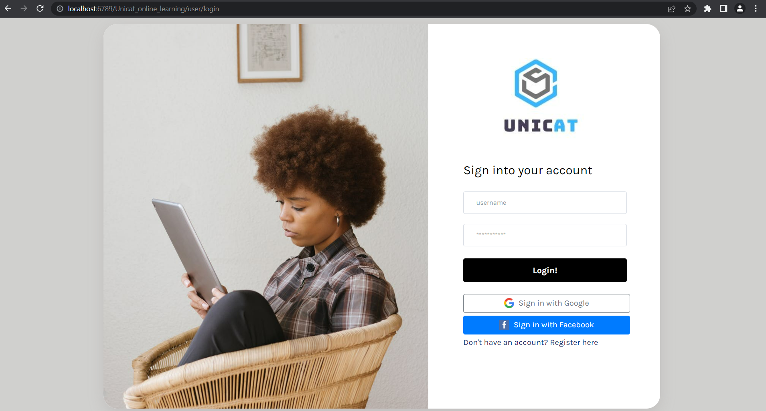

|  |  |  |  |  |
| --- | --- | --- | --- | --- |
| **ID and Name** | **12 - Login** | | **Actor** | Student, Tutor, Admin |
| **Description** | This function allows user to login into the website | | | |
| **Trigger** | /user/login | | | |
| **Preconditions** | **N/A** | | | |
| **Post-conditions** | **POST-1** User enter valid information | | | |
| **Normal Flows** | **Actor actions** | **System responses** | | |
| 1.Actor clicks the “Register or Login” button on the top of the screen.  2. Enter valid information and click the ‘Login’. | 1. Request back to the Login page if username,password not valid with roles or database. 2. Request to HomePage if the username, password match with the database. | | |
| **Alternative Flows** | **A1.** Actor can click the “login with facebook” button  **A2.** Actor can click the “login with gmail” button | | | |
| **Exception Flows** | **N/A** | | | |
| **Business Rules** | **N/A** | | | |

### ***3.5.7 Register***



|  |  |  |  |  |
| --- | --- | --- | --- | --- |
| **ID and Name** | **13 - Register** | | **Actor** | Guest |
| **Description** | This function allows guest to register an account to sign in into website | | | |
| **Trigger** | /user/register | | | |
| **Preconditions** | **N/A** | | | |
| **Post-conditions** | **User enter valid information to register** | | | |
| **Normal Flows** | **Actor actions** | **System responses** | | |
| 1.Actor clicks the “Register or Login” button on the top of the screen. Click the ‘Register’ button.  2. Enter valid information to register | 1. Notify alert if any input of information is not valid 2. if all information is valid. Create new User in database and request user to LoginPage to login | | |
| **Alternative Flows** | **N/A** | | | |
| **Exception Flows** | **N/A** | | | |
| **Business Rules** | **BR-3, BR-05, BR-06** | | | |

# *4. Non-Functional Requirements*

## *4.1 External Interfaces*

### ***4.1.1 User Interfaces***

UI-1: The GUI is suitable for display on the computer.

UI-2: The layout of the screen is streamlined, easy to operate, and implemented for the user.

UI-3: Use icons to provide visual insights to users.

UI-4: The text colour should be black except for some special texts.

UI-5: Tables appearing on the system must have filter and sort functions.

UI-6: Buttons, links, checkboxes, radio buttons are easy to click to use.

### ***4.1.2 Hardware Interfaces***

No hardware interfaces have been identified.

### ***4.1.3 Communications Interfaces***

CI-1: The system shall send an email to the user’s email to get new password when user forgot her/his account password.

CI-2: Users use a mouse to communicate with applications to handle functions that use need.

CI-3: The system shall display a text message to notify about the result of the function that the user performed.

## *4.2 Quality Attributes*

### ***4.2.1 Usability***

• The language is English.

• The Front-end web application should support Chrome browsers.

• The function is divided into menu items for easier access.

### ***4.2.2 Availability***

• Web shall be available at least 98% of the time between 5:00 A.M and midnight local

time, and at least 90% of the time between midnight and 5:00 A.M local time, excluding scheduled maintenance servers.

### ***4.2.3 Performance***

• All pages have loading speed less than 3 seconds on average

• The system can support up to 500 requests at the same time; The system allows up to

1200 students register in the system per semester.

• The system shall display confirmation messages to users within an average of 1.5

seconds and a maximum of 3 seconds after the user submits information to the system..

### ***4.2.4 Security***

• HTTPs between client and server.

### ***4.2.5 Safety***

• The system shall not spread viruses into the devices of users.

• The system shall not include any harm information for users.

• The system shall notify the user to confirm when performing any function that affects the database.

### ***4.2.6 Support Documents***

• Class libraries, framework, etc shall be described in System Design document (part VI).

• Web system shall develop the User Guides document for users (part VI).

# *5. Requirement Appendix*

## *5.1 Business Rules*

|  |  |
| --- | --- |
| **ID** | **Rule Definition** |
| BR-01 | Only verified users can log in successfully and access the system. |
| BR-02 | Users only can access information that belongs to their own, except admin. |
| BR-03 | Each field is not blank. |
| BR-04 | Each question only have 3 answers |
| BR-05 | Valid gmail([...@gmail.com](mailto:...@gmail.com)) ,phone (10-11 number),Date of birth(< now) |
| BR-06 | Password must greater than 8, Re-password must match with password |
| BR-07 | Username and Gmail doesn’t duplicate in the database |

## *5.2 Common Requirement*

• The pop-up form is used for functions such as viewing, adding, editing, and deleting.

• Account in the database is not deleted when using the delete function; instead, it is changed from enabled to disabled.

• The system must display the result of performing a data-related function at the end of the function.